**Mirrorsafe**

**Stronger Safer Guarenteed**

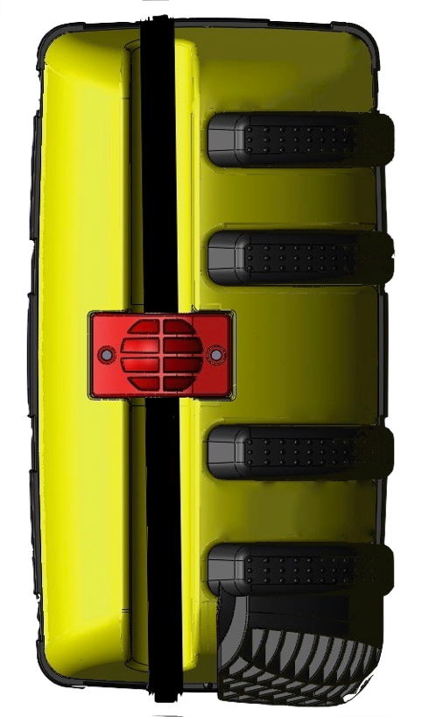

The **Mirrosafe Guarentee**

Mirrorsafe mirrors have been exhaustively tested to ensure they remain intact after a collision. Mirrorsafe are proud to announce that each Mirror is guaranteed to be unbreakable. With such unwavering trust in the design, materials and product quiality, Mirrorsafe guarantee to replace any mirror that does not meet our excellent standards for free.

**Cylist, pedestrian protection**

Cyclist/Pedestrian bumper fitted to the lower portion of the mirror is made of a soft compound rubber to prevent injury in the event of an impact with a cyclist or pedestrian. Mirrorsafe are very proud to confirm it’s innovative design for this bumper is the first time the industry has addressed the dangers that HGV mirrors pose to the public and have carried out extensive testing to minimise the efffect of such an impact.

* Never pay for a another replacement mirror.
* Never lose man hours waiting for a replacement mirror to be fitted.
* Increase KPI’s by eradicating down time of the vehicle in the event of a mirror breakage.
* Save replacement mirror, Engineer call out and labour costs.
* High visibilty design allowing oncoming vehicles more time to correctly assess the actual width of the oncoming vehicle thus increasing the ability to avoid a collision.
* Natural hazardous colour perfect to alert oncoming vehicles, motorcyclists, cyclists and pedestrians to the potential risk of an impact.
* Cyclist and pedestrian soft compound fitted to the underside of the mirror dramatically reducing the risk of serious injury.
* Patented innovative design assuring quality, performance and guaranteed to be unbreakable.
* Costs comparable to a standard manufacturer supplied mirror.
* Universal fitment.

Lorem ipsum dolorsit amet, conse ctetuer adipiscing elit, sed diam nonummy nibh euismod elit adispe.

Feugait nulla facilisi. Lorem ipsum dolorsit amet, conse ctetuer laoreet dolore magna aliquam erat volutpat.

Magna aliquam erat volu isi enim ad minim veniam melo eratta dolore magnus.

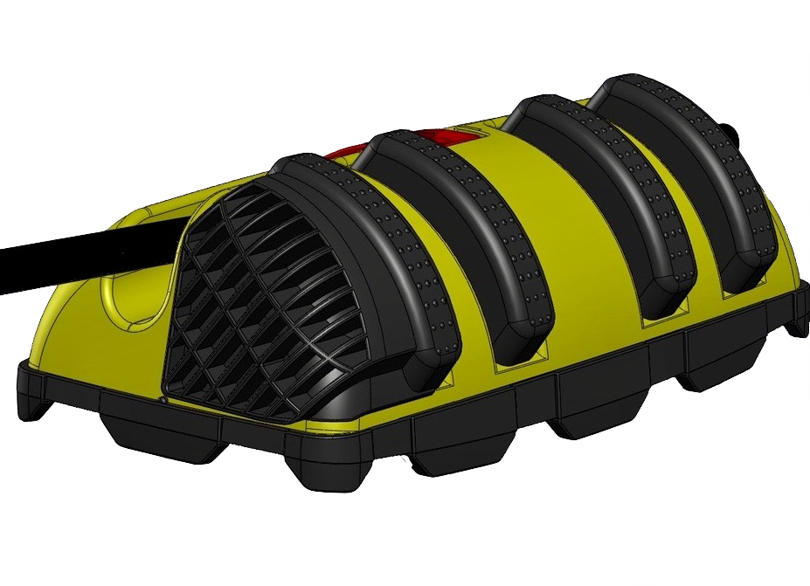

MirrorSafe fitment

Thanks to it’s universal fitment ball joint Mirrorsafe mirrors are compatible with the majority of manufacturer’s, this reduces further extensive down time of the vehicle searching for the correct mirror in the event of an impact.

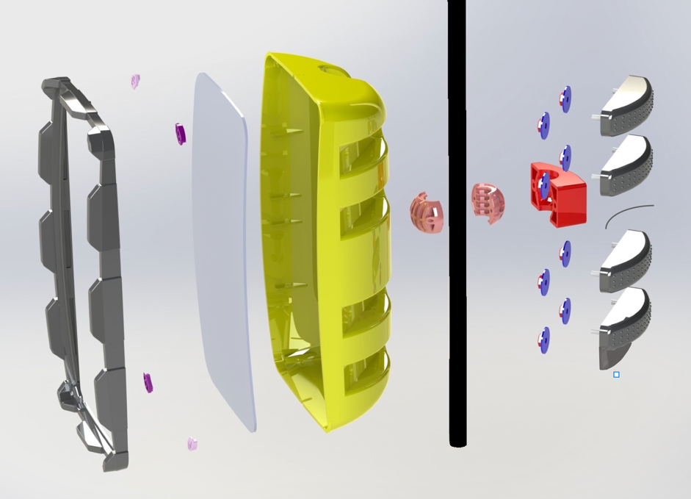

**Forward Facing Ribs**

Forward facing ribs ensure that the frontal impact is dampened further reducing acceleration of the mirror arm towards the body of the vehicle, reducing impact noise and prevention of damage to the mirror case.

**Cyclist/Pedestrian impact Rib**

Mirrorsafe are very proud to incorporate this feature into it’s design, we have identified the risk that HGV mirrors pose to pedestrians and especially cyclists and motorcyclists. HGV mirrors vary in height dependant on manufacturer but most are head height and can travel at speeds of up to 56 mph which can cause catastrophic injuries. Mirrorsafe’s cyclist impact rib is designed to deflect the object on impact and of a soft composite rubber which which ensures injuries are greatly reduced.

**Rear Facing Rib**

Early in testing it was discovered that when a mirror impacts with an object it is not the initial strike that breaks the glass but the mirror arm being forced in towards its own body. The force in which the mirror is propelled inwards crashes the mirror glass against the door and window. The resulting impact breaks the mirror glass and can actually smash the window and damage the door, Mirrorsafe have measured the noise produced by the impact and have recorded examples of over 200 decibels. The resulting noise created can force the drivers instinct to swerve away from the noise thereby causing a much bigger accident onsingle lane roads. The mirrosafe rear rubber rib dampens the impact to such an extent that it prevents the mirror from being broken, the window being smashed, damage to the door and reduces the noise by as much as 80%, thereby reducing the risk of the driver swerving unneccesarily.

**If you require any further information please do not hesitate to contact us via any means listed below:**

**MirrorSafe Ltd Lillo G Banetta**

**Unit 5 Bridge Industrial Estate lillo.banetta@mirrorsafe.co.uk**

**Newhaven www.mirrorsafe.co.uk**

**East Sussex Tel: +44 7584579504**

**BN9 0HE**

**Tel: 01273 510204**

[**info@mirrorsafe.co.uk**](mailto:info@mirrorsafe.co.uk)

[**www.mirrorsafe.co.uk**](http://www.mirrorsafe.co.uk) **Mirrorsafe Ltd Company Reg: 10554822**

Mirrosafe are proud to announce that it has commenced with full UK production of its safety products, this investment in the UK operation underscores the Mirrorsafe ongoing commitment to the economy and its customers.

Excellent products and superior customer focus allow Mirrorsafe to be an International leader in the production and distribution of Road Safety Products. Mirrorsafe provides its customers with innovative solutions which hugely decrease the risks involved with operating heavy goods vehicles on UK roads. The ever evolving world of logistics where there is ever more demand for productivity and efficiency, it is equally important that health and safety performance grows in tandem with these demands.

It is with the synergy between productivity and health and safety that Mirrorsafe improve it’s clients ability to achieve optimum levels of performance, it is with our unwavering dedication to it’s clients, Mirrorsafe will progress with them.

**Universal Ball joint**

The mirrorsafe universal ball joint allows the mirror to be fitted to the majority of HGV vehicle’s on the market. The design is the perfect synergy of practical and simple application and durable dependability. Installation is achieved by simply bolting both sides together around the mirror arm using the 2 bolts supplied, bolt the ball joint clamp into place and adjust the mirror angle as required and the vehicle is ready to go.

**Ball Joint Clamp**

The ball joint clamp also boasts optimal composite materials as the case ensuring excellent durability. The clamp fits over the universal ball joint with two bolts ensuring ease of installation.

**Mirror Case**

The Mirrorsafe case demonstrates the synergy between industry leading design and optimal materials, allowing it to withstand the force of a class 1 lorry driving over it without breaking.

Its innovative design ensures not only durability but the very best in production quality enabling us to guarantee our mirrors in any collision encountered when fitted to the vehicle.